**DRHS Career Center-Quick Guide-*Seniors***

**START**

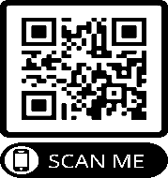

**College Board.com**

**ACT/SAT**

**CAREER CENTER CALENDAR**

DAMONTE RANCH HS **CAREER CENTER** **Home**

gcabada@washoeschools.net

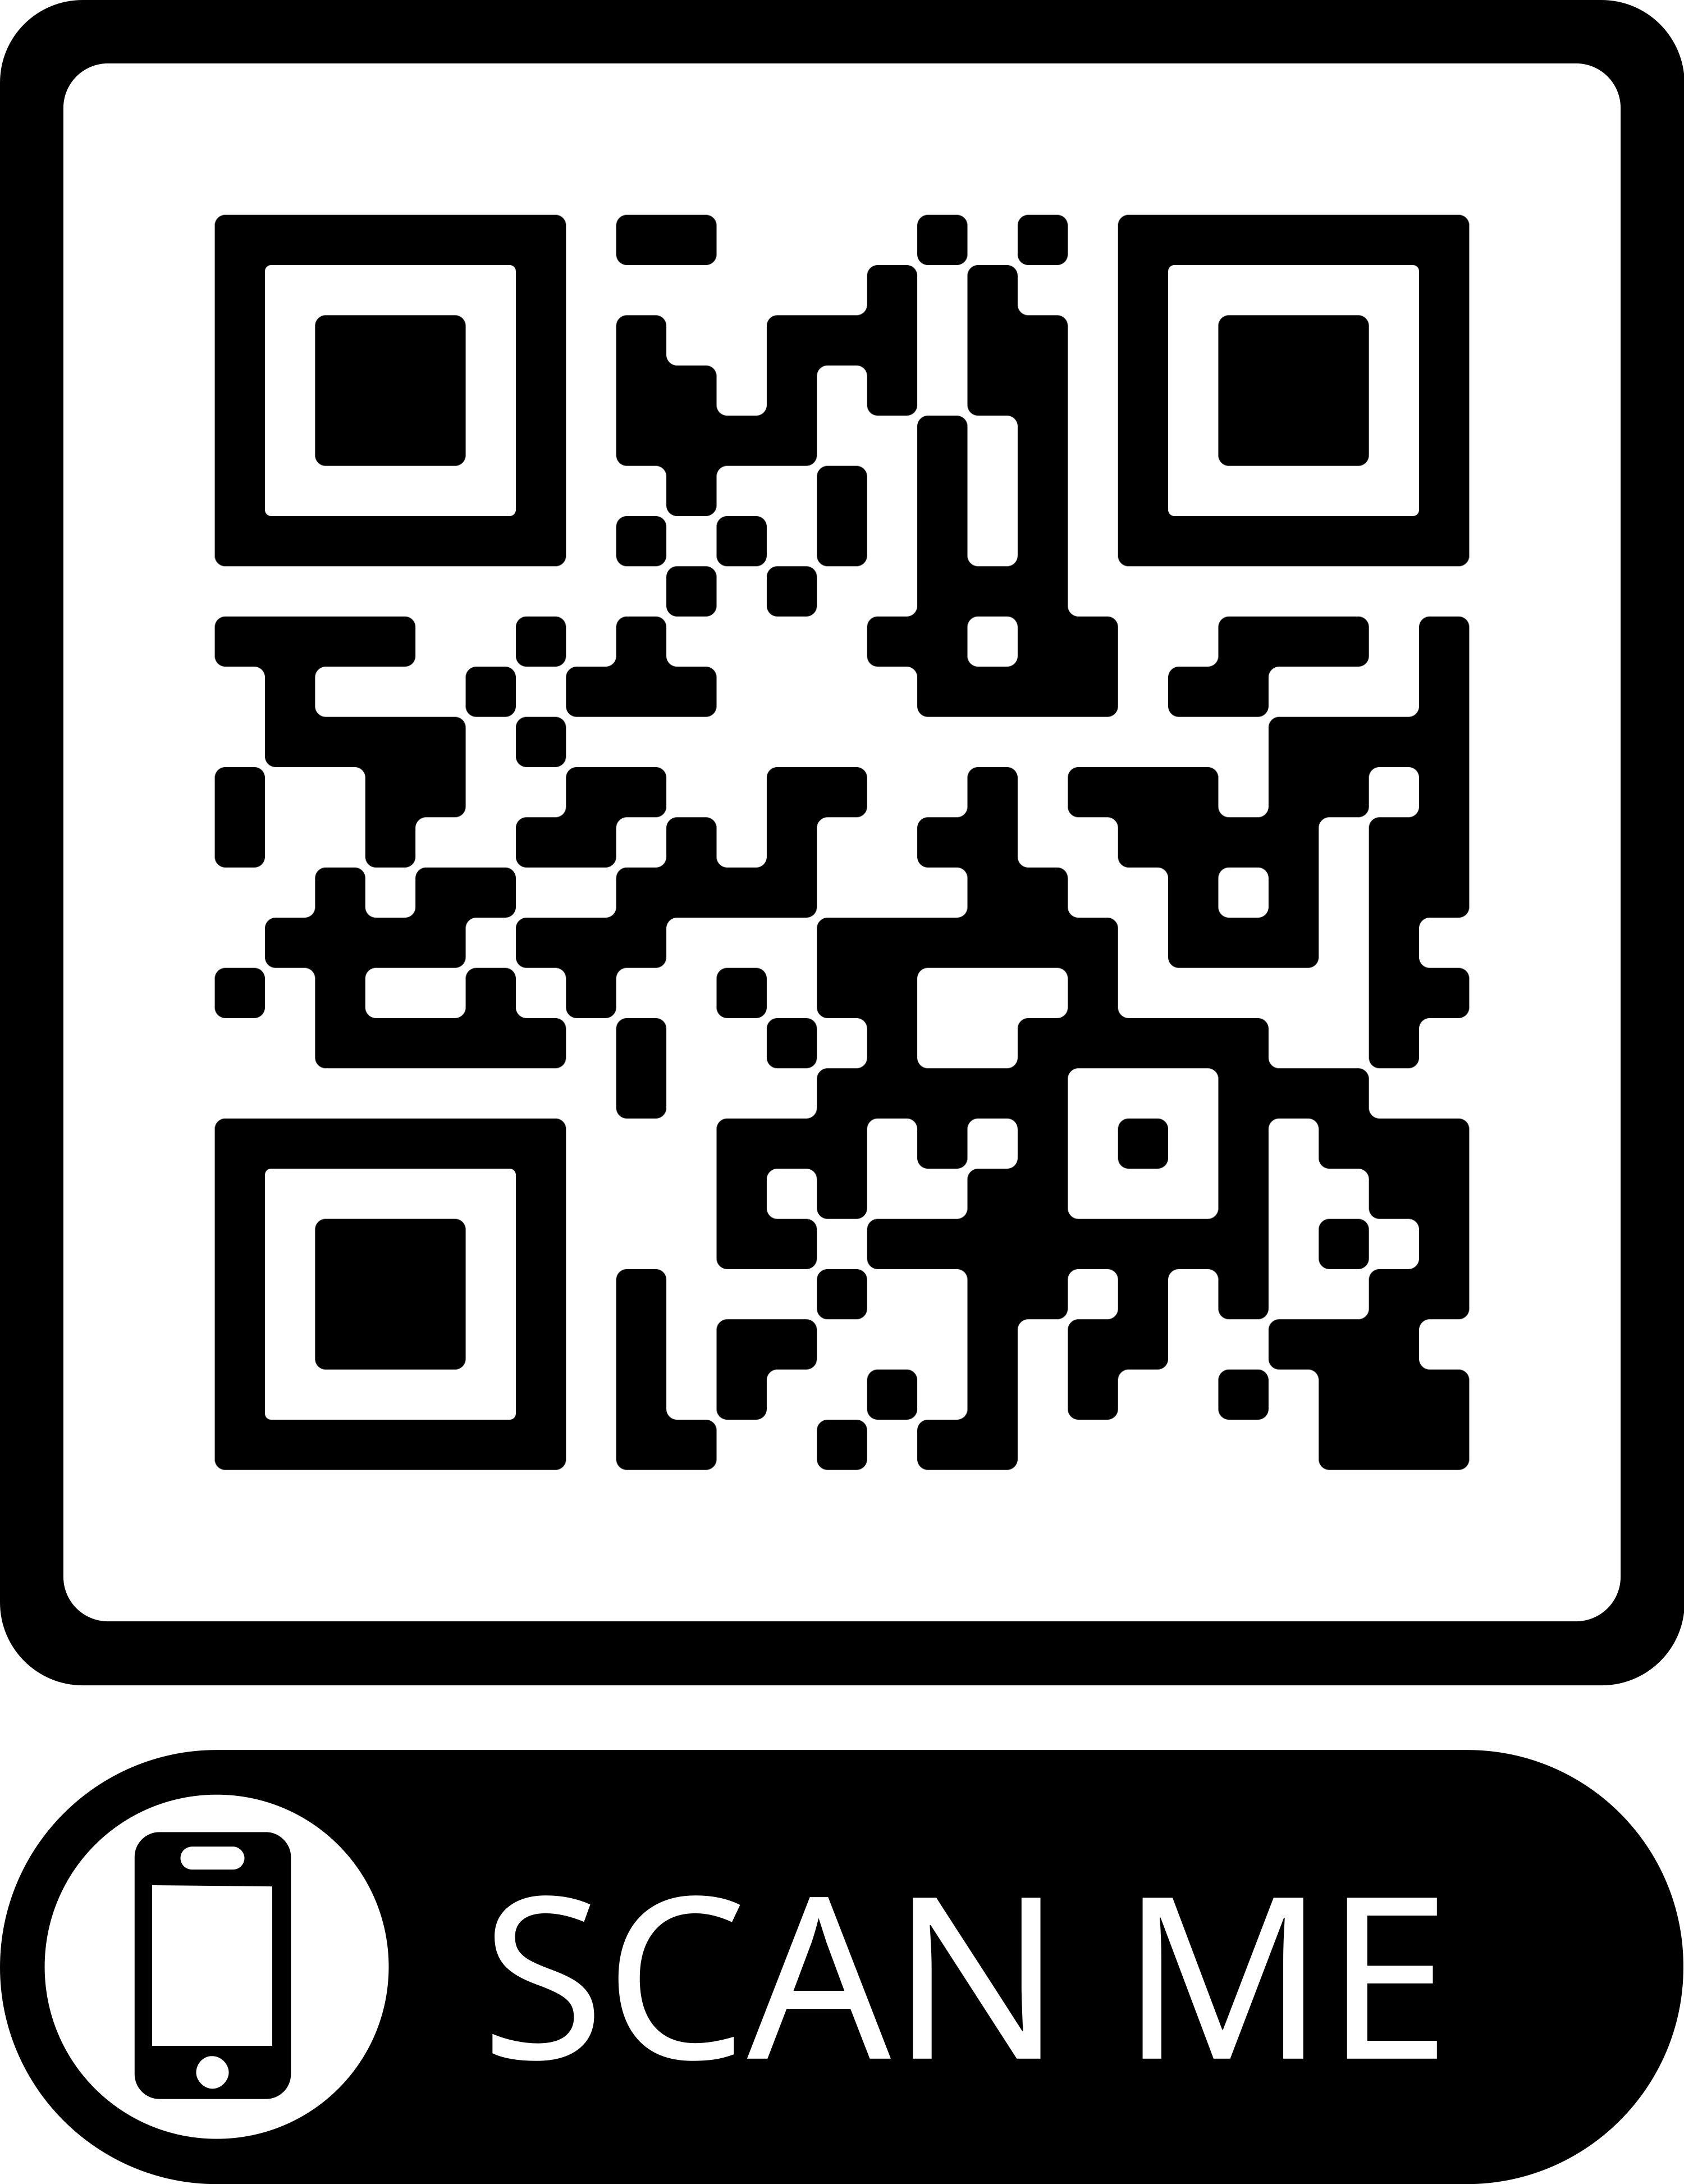

**Canvas.** [**https://washoe.instructure.com/**](https://washoe.instructure.com/)

**Class of 2024**

**ASVAB Career Exploration Test**

**Spring & Fall**

**DRHS DRHS Facebook Parent Group**

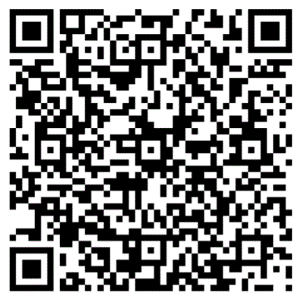

**DRHS**

**IN-HOUSE Scholarship**

**Nov 1-Jan 19**

**TMCC Nevada Promise deadline Oct 31**

**Graduation!!**

**Check Status**

**DRHS Scholarships**

**Military Options**

**Northern Nevada Scholarship Program**

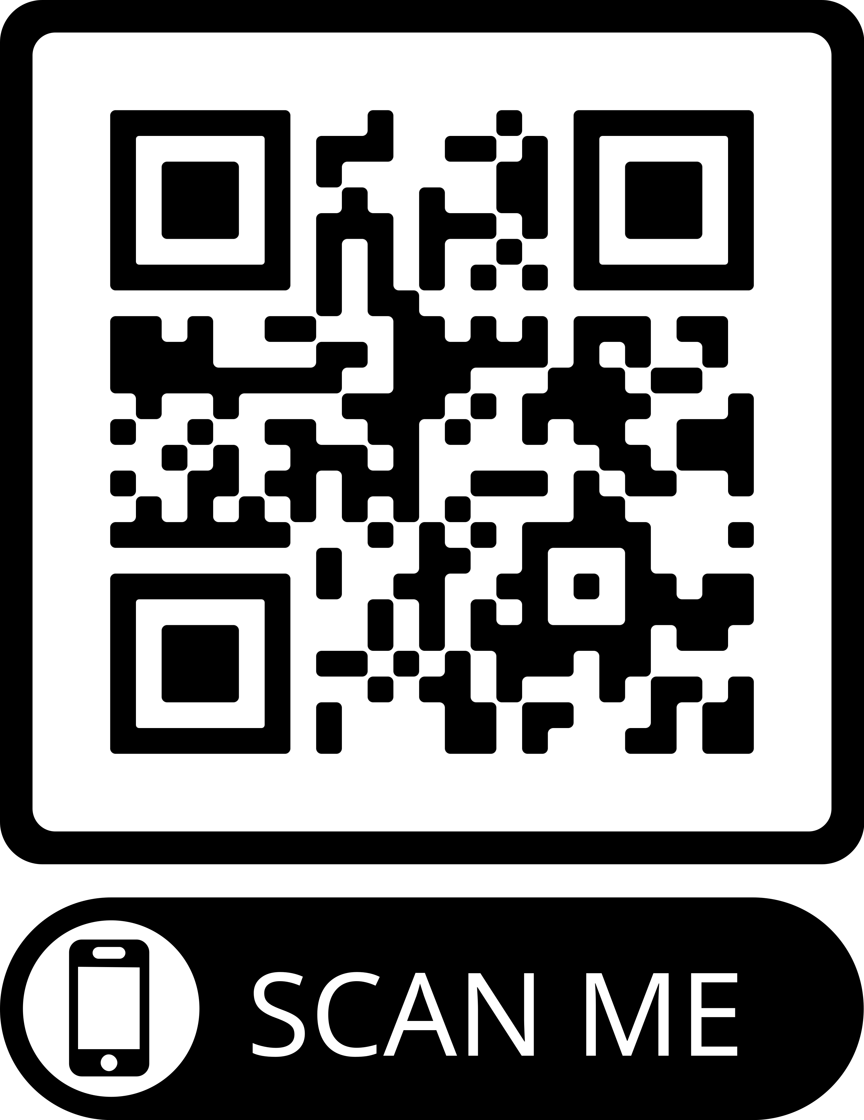**Technical/**

**Vocational**

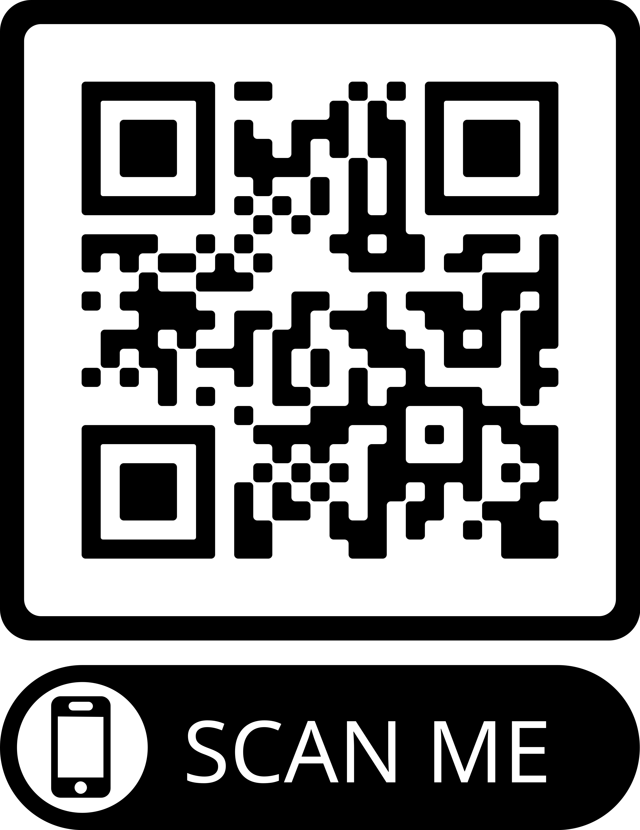

**Trades/**

**Apprenticeship opportunities**

**FAFSA**

**Opens JANUARY 1, 2023**

**Common App**



**WUE**

**Princeton Review Advice**

**Princeton Review**

**TMCC-Apply**

**UNR-Nevada Bound**

**UNR-Apply**

**UNR Scholarships**

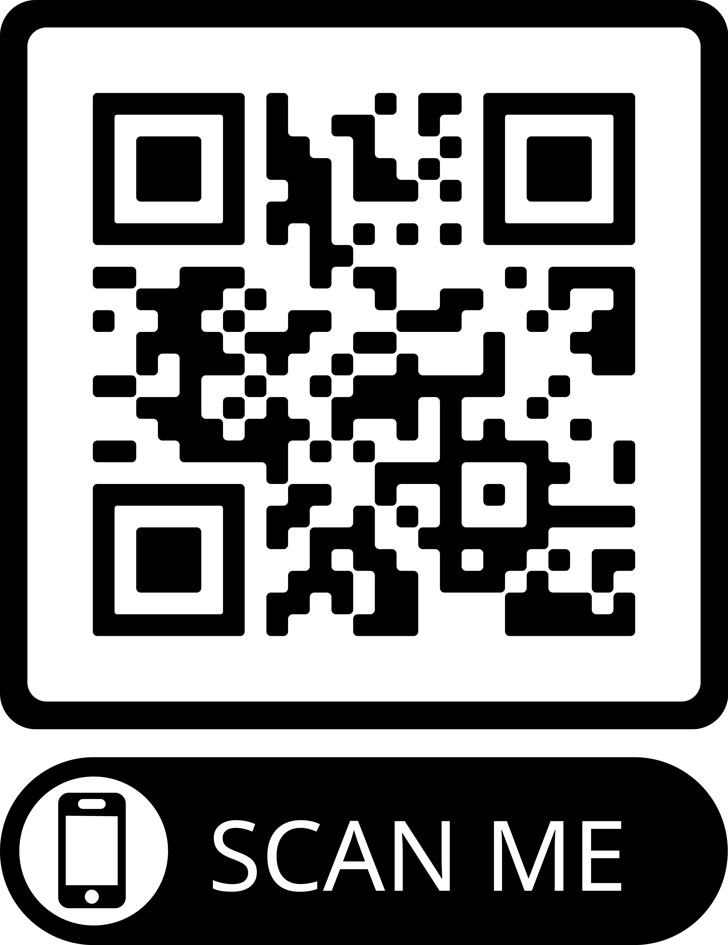

**Admission UC Schools**

Scriborder-

**OFFICIAL Transcript** Request

**Sports_D1/D2**

**NCAA Eligibility Center**

